**DBS LAB**

**Project Proposal**

**Web Application**

**POINT OF SALE SYSTEM**

|  |  |  |
| --- | --- | --- |
| **Member 1** | **Name** | Muhammad Hamza Fayyaz |
| **Registration No.** | 19-CS-20 |
| **Member 2** | **Name** | Muhammad Abdullah Zahid |
| **Registration No.** | 19-CS-54 |
| **Member 3** | **Name** | Muhammad Moin Bukhari |
| **Registration No.** | 19-CS-40 |

**Submitted To:**

Sir Awais Awan

**INDEX:**

|  |  |
| --- | --- |
| **Sr. No.** | **Topics** |
| 1 | Abstract |
| 2 | Introduction |
| 3 | Problem statement |
| 4 | Scope of the project |
| 5 | Tools and technologies required |
| 6 | Project timeline |
| 7 | Introduction of the team members |
| 8 | Conclusion |

**POINT OF SALE SYSTEM**

1. **Abstract:**

A consumer makes a payment for items or services at a shop using a point-of-sale system(POS). Simply explained, a consumer completes a point-of-sale transaction every time he/she makes a purchase. The point-of-sale system is the heart of your business; it's where everything comes together, including sales, inventory management, payment processing, and client management. Modern point-of-sale systems are frequently programmable or may be enhanced with third-party software. These systems may be customized to fulfil a variety of requirements.

One of the most common uses of POS terminals is in the retail industry. A cash register is usually included in a retail point of sale system (which in recent times comprises a computer, monitor, cash drawer, receipt printer, customer display and a barcode scanner).

The POS unit is responsible for customer sales, although it is only one component of the whole POS system utilized in a retail establishment. Other POS system tasks, including as inventory control, purchasing, receiving, and moving items to and from other locations, are generally handled by "back-office" computers. Store sales information for reporting, sales trends, and cost/price/profit analysis are all common uses of a POS system. Customer information may be kept on file for the administration of receivables, marketing, and particular purchase analysis depending on the demands of the business.

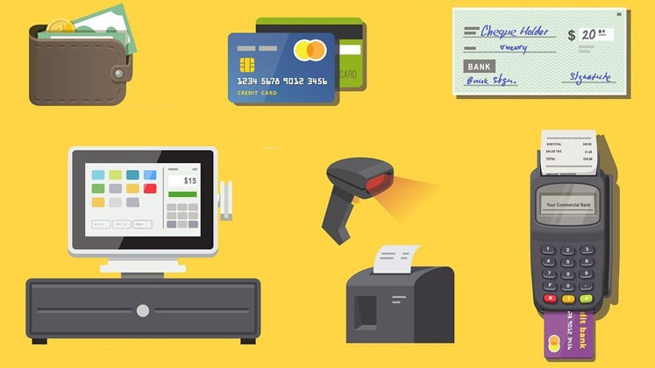

1. **Introduction:**

The goal of the study is to create a system that will assist the firm improve their manual processes in processing and monitoring daily sales transactions by being efficient, accurate, and severe. Customers' orders and receipts will be managed proactively by the P.O.S. system at their retail stores. In addition, the business will have access to complete sales data and sales history. To measure their business progress, simple comparisons between date ranges may be done. The project ‘Point of Sale System’ will enable the business to have the control over their transactions, and inventory.

A smart business is continuously looking for new and more effective ways to do arduous tasks. The business needs a reliable and accurate computerized point-of-sale system that will guarantee income, give accurate and thorough sales statistics, also keep track of their inventory/stock, from which supplier the product came from, and which employee received the order on the behalf of the business. A retail transaction is performed at a point of sale (POS) system. It's when a consumer pays a cashier in return for products or services.

1. **Problem statement:**

How can we develop a computerized point-of-sale system to assist the retail company/business conduct their everyday transactions more effectively and accurately? - The main challenge that we are trying to solve is how to develop a Computerized Point of Sale System that will allow the business to complete and monitor daily transactions in a more efficient and accurate manner.

1. **Scope of the project:**

The scope of this project includes solutions for managing the employee data, sales data, sales made by each employee, managing products inventory, product category, calculating total sales. The system will control and manage the employee personal database such that specific users with different role types as manager, administrator, simple cashier etc. All the employees will be able to manipulate the systems database based on their given access privileges. This software will provide authentication and authorization mechanism. Every user with specific role type can be able to login to the system with his/her username and password and have access to the system of which the access is granted.

File maintenance

It manages all the information about adding, viewing, editing and deleting of files of the business in the system. Product Maintenance -manages the available products of the company in the inventory of the system. Product Category Maintenance -manages the category of products in the system.

Transaction

It is in charge of the entire system's transactions. It contains a list of employees, as well as their individual sales and overall sales. The administrator/owner of the company uses reports to keep track of sales and products available in their bakery. Only the owner/administrator has access to this menu.

1. **Tools and technologies required:**

The tools and technologies required for this project are listed below:

* + Microsoft SQL Server 2019
  + Microsoft SQL Server Management Studio
  + ER-win Data Modeler 2020R2
  + XAMPP
  + VS Code
  + HTML
  + CSS
  + PHP

1. **Project timeline:**

The Project was Assigned to us on 21st of June, 2021 and we started our work on the project after out End Semester Examination of the semester and vivas.

|  |  |
| --- | --- |
| **Date** | **Status** |
| 24-july-2021 | We Initially drew a rough ERD of our project serve as the basis later on in the creation of the actual database. |
| 25-july-2021 | Developed basic html/css for the web apps structure |
| 26-july-2021 | Created the Database in SQL Server and connected it to PHP using XAMPP. |
| 28-july-2021 | Inserted All the queries in out web app an made necessary changes |

1. **Introduction of the team members:**

There are three members in the group. All Group Members Contribute Equally to Meet the Requirements of Our Proposed Point-of-Sale System. We worked for approximately five days on the Point-of-Sale System’s database schema, its front end and beack end in HTML / CSS / PHP, and connected Microsoft SQL Server with PHP using XAMPP.

The Name and Registration number of the three group members are:

* Muhammad Abdullah Zahid 19-CS-54
* Muhammad Hamza Fayyaz 19-CS-20
* Muhammad Moin Bukhari 19-CS-40

1. **References:**

This Project of Point-of-Sale System help us to understand the deep concept of designing a data base and this project also helped us all to learn about use of data base with GUI and an application instead of just writing the queries in SSMS. Some of the Key features of this project are:

* Separate views for different role levels.
* Admin role
* Stock Manager role
* Cashier role
* Product inventory
* Sales receipt making
* Keeping record of suppliers and our purchase orders
* Keeping track of total sales
* Notifying stock manager when an item is low in stock so that he can create a purchase order.

-----------------------------------End-----------------------------------